Green Stream Energy Data Pipeline Design

Task A: ETL Architecture Diagram:

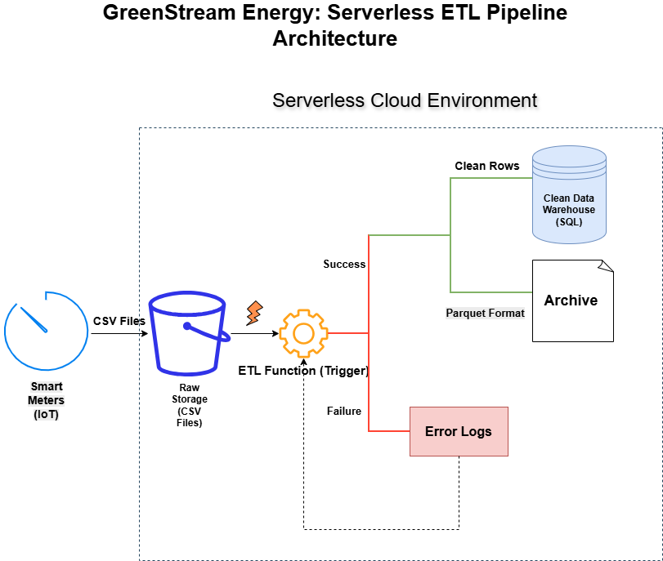

Task B: Transformation Logic & Business Rules:

Rule Name | Business Logic Description
1. Unit Standardization | Check the unit column. IF unit is "W" (Watts), divide the reading value by 1000 and update unit to "kW". ELSE keep value as is.
2. Missing Values Handling | IF reading is NULL or empty, flag the record as "Incomplete" and exclude it from peak-usage aggregations (do not delete, just flag).
3. Faulty Meter Detection | IF a meter reports consumption = 0 for more than 24 consecutive hours, flag the MeterID as "Potential Faulty" for maintenance review.
4. Data Format Optimization | Convert the final cleaned data from row-based CSV to columnar Parquet format to optimize storage and query speed for historical analysis.

Task C: Single Record Lifecycle:
Step-by-Step Lifecycle of a Smart Meter Record:
- Ingestion: A smart meter in a household sends a raw CSV file (containing reading: 1500 W) to the cloud Raw Storage (S3).
- Triggering: The arrival of this file automatically triggers the serverless ETL Function (Event-Driven Architecture).
- Validation & Transformation: The function reads the record. It detects the unit is "W", so it applies Rule #1 (divides by 1000) to convert it to 1.5 kW. It also checks for NULLs.
- Loading (Structured Storage): The cleaned record (1.5 kW) is inserted into the Data Warehouse for immediate reporting.
- Archiving: A copy of the clean data is converted to Parquet format and saved in the Archive Storage for future Machine Learning tasks.
- Error Handling: If the record was corrupt or had invalid formats, it would have been routed to the Error Logs for manual inspection, bypassing the warehouse.

